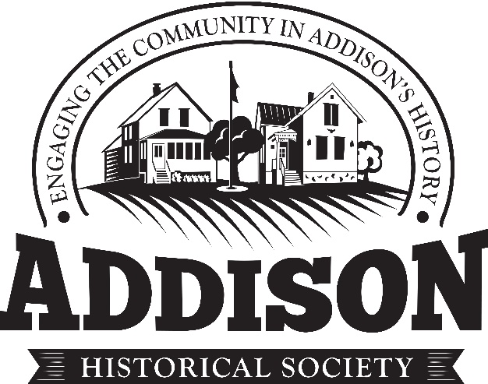
Our Commitment to Our Donors
We will not sell, share or trade our members’ and donors’ names or personal information with any other entity, nor send mailings to our members and donors on behalf of other organizations
This policy applies to all information received by the Addison Historical Society and Museum, both online and offline, on any as well as any electronic, written, or oral communications.
To the extent any donations are processed through a third-party service provider, our donors’ information will only be used for purposes necessary to process the donation.

